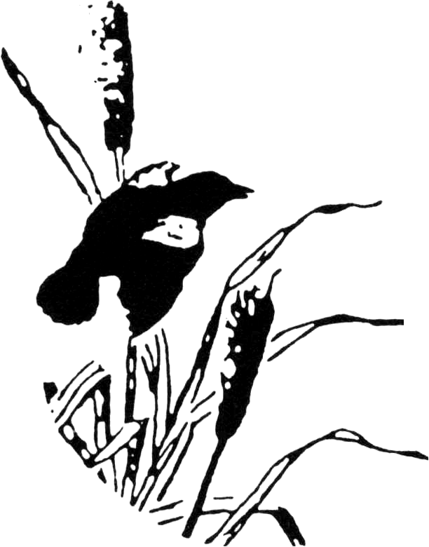
Town of Stanford Conservation Advisory Commission
Town Hall
26 Town Hall Road
P.O. Box 436
Stanfordville, NY 12581

Final Minutes

February 16, 2011

The Conservation Advisory Commission convened their monthly meeting at the Town Hall on February 16, 2011. The meeting was called to order at 5:10 pm by Chairperson, Lisa Kilmer.

Members present: Beth Ashton, Barry Haydasz, Lisa Kilmer, Brenda Lynch, Mike Picinelli,
Members absent: Karen Sergio, Charlie Shaw, and Tom Dewhirst (Liaison to the Town Board)

Minute’s approval
Lisa made a motion to approve the January 2011 minutes with changes. Brenda seconded the motion and all were in favor.

New Business
Blue Bird Box Project
With the Wilser family in attendance, we skipped to this item under new business. Alice Wilser was interested in making bluebird boxes to satisfy a community volunteer requirement for the attainment of her black belt. It was decided that she, along with her family, would build 6 boxes that will be installed at the Stanford Wildlife Preserve. They were interested in installing the boxes in March and would follow up with the CAC to determine locations for installation.
Old Business
Master Plan
We started off the discussion by reviewing the various emails from the Master Plan Committee and Nina Peek. We then reviewed the list of questions for the CAC that Nina had sent and came up with a response which Lisa will formalize and send to Nina and the committee.

Beth made a motion to adjourn the meeting. Barry seconded the motion and all were in favor. The meeting was adjourned at 7:35 pm. The next meeting will be held on March 16th at 6p.m.

Minutes respectfully submitted by Beth Ashton.

