TOWN OF STANFORD TOWN BOARD
END OF TEAR MEETING
DECEMBER 29TH, 2021

The Town of Stanford Town Board convened for their December End of Year meeting on Wednesday, Dec. 29th, 2021 via Zoom. Supervisor Wendy Burton called the meeting to order at 7:00 pm with the Pledge of Allegiance led by Clerk Ritamary Bell.
Roll call: Wendy Burton – present
Margaret Fallon – present
Mary Weinberger – absent
Paul Coughlin – absent
Frank Pepe – present

PRIVILEGE OF THE FLOOR:
No one addressed the Board.
Supervisor Burton said that she is keeping the Town’s website and Facebook page up to date to let residents know of the availability of Covid home tests kits. They may be in on Friday but reminded all that there is a limit of one per household and no one can come back to get more if picked up one previously.

MOTION TO ACCEPT THE AGENDA:
A motion was made by Wendy Burton, seconded by Margaret Fallon, to accept the agenda as presented. Motion carried with all present voting in favor.

NEW BUSINESS:
1. APPROVE CHRIS McNAMARA’S APPOITMENT TO THE RECREATION COMMISSION: A motion was made by Wendy Burton, seconded by Frank Pepe, to appoint Chris McNamara to the vacant position on the Rec. Commission. Motion carried with all present voting in favor.

2. RESOLUTION #12G - LIPSKY/KELLY TAX CERTIORARI: The following resolution was briefly described by Supervisor Burton and said that it will be in its entirety in the Minutes.
RESOLUTION #12G
APPROVAL OF LIPSKY / KELLY TAX CERTIORARI
Motion made by Wendy Burton, seconded by Frank Pepe:
Whereas the Supreme Court of the State of New York, County of Dutchess, has come to an agreement in the assessment dispute between the parties LIPSKY & KELLY and the TOWN OF STANFORD, the BOARD OF ASSESSMENT REIEW and the ASSESSOR OF THE TOWN OF STANFORD,
Now therefore be it resolved that the Town Board of the Stanford Town accepts the decision as follows:
SUPREME COURT OF THE STATE OF NEW YORK
COUNTY OF DUTCHESS
--------------------------------------------------------------------------X
In the Matter of the Application of
CONSENT JUDGMENT
ANDREW A. LIPSKY and
HOLLY M. KELLY,
Petitioners,
For a Judicial Review under Article 7 of the Real Property INDEX NOS. 2020-52176
Tax Law of Real Property Tax Assessments, 2021-52912
-against- ASSIGNED JUDGE:
Hon. James. V. Brands, J.H.O.
THE TOWN OF STANFORD, the BOARD OF
ASSESSMENT REVIEW and the ASSESSOR
OF THE TOWN OF STANFORD,
Respondents,
-and-
WEBUTUCK CENTRAL SCHOOL DISTRICT,
Town Board End of Year Minutes
12/29/21, page 2
Intervenor-Respondent.
--------------------------------------------------------------------------X
The above petitioners having heretofore served and filed a Notice and Verified Petition to review the tax assessment fixed by the Town of Stanford for the assessment rolls of 2020 and 2021 upon certain real property located in the Town of Stanford, Dutchess County, New York and designated on the Official Assessment Map of the Town of Stanford for Parcel Tax Identification Number 135200-6868-00-821263-0000 (689 Bangall Amenia Road); and
The petitioners having appeared by Jeffrey Rothschild, Esq. of the law firm of Cappillino, Rothschild & Egan LLP, the respondents having appeared by Ian S. MacDonald, Esq. of the law firm of Mackey Butts & Wise LLP, attorneys for the Town of Stanford, and the Intervenor-Respondent, Webutuck Central School District, having appeared by Christopher P. Langlois, Esq. of the law firm of Girvin & Ferlazzo, P.C, and the parties having made their settlement, it is hereby
ORDERED, that the assessment on the property referred to herein, be and the same is hereby reduced, corrected, and fixed for the 2020 and 2021 assessment rolls as follows:
DESCRIPTION (Tax Identification Number): 135200-6868-00-821263-0000
(689 Bangall Amenia Road)
Assessment Original Settlement Amount of AG Taxable
Roll Assessment Assessment Reduction Exemption Assessment
2020 $4,825,100.00 $3,800,000.00 $1,025,100.00 $361,440.00 $3,438,560.00

Assessment Original Settlement Amount of AG Taxable
Roll Assessment Assessment Reduction Exemption Assessment
2021 $4,825,100.00 $3,800,000.00 $1,025,100.00 $360,900.00 $3,439,100.00
ORDERED, that the assessment on the property referred to herein, shall remain at $3,800,000.00 and shall not be increased for the 2022 and 2023 assessment rolls except in the event there is a physical change (improvement to the property), and it is hereby
ORDERED, ADJUDGED AND DECREED, that the reduction to the assessment shall be applied only to the improvements on the parcel, and it is further;
ORDERED, ADJUDGED AND DECREED, that the officer or officers having custody of the assessment roll upon which the above-mentioned assessment and any taxes levied thereon are entered shall correct the said entry in conformity with this Order and shall note upon the margin of said roll, opposite of said entry, that the same have been corrected by the authority of this Order, and it is further
ORDERED, that there shall be audited, allowed and paid to the petitioners by the Dutchess County Commissioner of Finance for Parcel Tax Identification Number 135200-6868-00-821263 (689 Bangall Amenia Road), the amount of Dutchess County, Special District and any other ad valorem taxes paid by the petitioners as taxes against the said erroneous assessments in excess of what the taxes would have been had the said assessments made in the aforesaid years been determined by this Order, together with interest thereon from the date of payment thereof as provided by statute, provided, however, notwithstanding any other provisions herein to the contrary, interest shall be waived in the event that payment is made within sixty (60) days from the date of service of this Order with notice of entry, and it is further,
ORDERED, that petitioners waive any refund from the Dutchess County Commissioner of Finance or the Town of Stanford for the 2020 and 2021 assessment rolls, relative to the amount, if any, solely of Town taxes paid by petitioners as taxes against the erroneous assessments in excess of what the taxes would have been if the said assessments made for the 2020 and 2021 assessment rolls had been determined by this Order; and it is further
ORDERED, that there shall be audited, allowed and paid to the petitioners by the Webutuck Central School District, for the Parcel Tax Identification Number 135200-6868-00-821263 (689 Bangall Amenia Road), the amount of school taxes, and library taxes if applicable, paid by the petitioners as taxes against the said erroneous assessments in excess of what the taxes would have been had the said assessments made in the aforesaid years been determined by this Order, together with interest from the date of
Town Board End of Year Minutes
12/29/21, page 3
payment thereof as provided by the statute, provided, however, notwithstanding any other provision herein to the contrary, interest shall be waived in the event that payment is made within sixty (60) days from the date of service of the Order with notice of entry, and it is further
ORDERED AND DIRECTED, that unless paid within sixty (60) days from service of this Order and of the Audit and Demand for payment all tax refunds are to be made with statutory interest for the date the taxes indicated herein were paid, pursuant to §726 of the Real Property Tax Law of the State of New York, and it is further
ORDERED AND DIRECTED, that all tax refunds hereinabove directed to be made by respondents, the Dutchess County Commissioner of Finance, Town of Stanford, Webutuck Central School District and/or any of the various taxing authorities, be made by check or draft payable to the order of Andrew A. Lipsky and Holly M. Kelly and mailed to Cappillino, Rothschild & Egan LLP, P.O. Box 390. Pawling, New York 12564, and it is further
ORDERED, that this Order hereby constitutes and represents full settlement of the tax review proceedings herein, and there are no costs or allowances awarded to, by or against any of the parties, and that upon compliance with the terms of this Order, the above-entitled proceedings be and the same are settled and discontinued.
ORDERED, that this Order may be executed and delivered by exchange of facsimile signatures of the parties, or by exchange by e-mail of signed copies bearing the signatures of the parties. The facsimile or e-mail signatures shall be the same as original signatures in all respects, including, but not limited to, being admissible in evidence in any court.
ORDERED, that this Order may be executed in counterparts.
Signing and entry of the within
Order is hereby consented to:
_______________________________ By: _______________________________
Jeffrey Rothschild, Esq. Ian S. MacDonald, Esq.
Cappillino, Rothschild & Egan LLP Mackey Butts & Wise LLP
Attorneys for Petitioner Attorneys for Respondents
7 Broad Street 3208 Franklin Avenue
P.O. Box 390 Millbrook, New York 12545
Pawling, New York 12564 (845) 677-6700
(845) 855-5444
_________________________________
Christopher P. Langlois, Esq.
Girvin & Ferlazzo, P.C.
Attorneys for Webutuck Central School District
20 Corporate Woods Boulevard
Albany, New York 12211
(518) 462-0300
Dated: , 2021
Poughkeepsie, New York
SO ORDERED
_______________________________
HON. JAMES V. BRANDS, J.S.C.

3. A.R.P.A. RESOLUTION: The following resolution was explained by Supervisor Burton that the ARPA funds will be moved from the NY Class account to the General Fund in order to buy better radios and other equipment for the Fire Company. RESOLUTION #12H OF 2021
TO TRANSFER FUNDS FROM AMERICAN RESCUE FUNDS ACCOUNT NY CLASS NY 01-0010-0009 AND MOVE THE FUNDS TO THE GENERAL FUND #3900018
Motion made by Wendy Burton, seconded by Frank Pepe:
Whereas the Town of Stanford will be investing American Rescue Plan funds build an interoperable emergency communications system.
Whereas the NY Class Account 01-0010-0009 American Rescue Fund Account contains funds for this purpose.
Town Board End of Year Minutes
12/29/21, page 4
Whereas the Town of Stanford will transfer funds from NY Class Account 00-0010-009 American Account to the Millbrook General Fund Account 3900018.
Now therefore be it resolved, the Supervisor is authorized to complete the following budget modifications and transfer the funds from the American Rescue Funds Account to the General Fund.
00-510 Estimated Revenue +15,889.00
00-4089 Federal Aid ARPA
00-960 Appropriations +15,889.00
00-01-1650-20 Communications Equip
00-200 Cash +15,889.00
00-209 Cash- ARPA
Resolution #12H of 2021 approved by the affirmative votes of the three Board members present and certified this 29th day of December 2022. Ritamary Bell, Town Clerk

4. RESOLUTION #12I: GENERAL AND HIGHWAY FUNDS BUDGET RESOLUTION: The following resolution was read by Supervisor Burton:
Motion made by Wendy Burton, seconded by Margaret Fallon as follows:
Whereas the Town of Stanford has expenditures for the adopted 2021 General Fund and Highway Fund budget lines that will exceed the amount of fund available in these certain budget lines, and
Whereas, the General and Highway Funds have funds available in other lines and needs to transfer such funds to provide for expenditures,
Now therefore be it resolved that the Town of Stanford Town Board hereby amends and transfers from and to budget lines listed below for FY 2021:
ACCOUNT DESCRIPTION INCREASE DECREASE
00-01-1220-40 Supervisor Contractual +$628.23
00-01-1315-40 Bookkeeper Contractual -$ 628.23
00-01-1220-49 Supervisor stamps +4.05
00-01-1315-40 Bookkeeper Contractual -$ 4.05
00-01-1355-40 Assessor Contractual +$3,502.57
00-01-1910-40 Unallocated Insurance -$3,502.57
00-01-1420-40 Attorney Contractual +$117.37
00-01-1315-40 Bookkeeper Contractual -$117.37
00-04-5132-40 Garage Contractual +$514.62
00-05-6510-40 Veterans Services Contr. -$514.62
00-06-7140-40 Playgrounds Contractual +$2,217.74
00-06-7310-40 Youth Program Equip -$2,217.74
00-07-8020-40 Master Plan Contractual +$3,111.20
00-01-1910-40 Unallocated Insurance -$3,111,20 Total Funds General: + $10,095.78 -$10,095.78
01-04-5140-40 Brush & Weeds +$1,541.87
01-04-5142-42 Salt -$1,541,87 01-04-5130-42 Parts +$8000.00
01-04-5142-42 Salt -$8000.00 Total Funds Highway +$9,541.87 -$9,541.87
Resolution #12I of 2021 approved by the affirmative votes of the three Board members present and certified this 29th day of December 2022. Ritamary Bell, Town Clerk
5. RESOLUTION #12J – RETIREMENT RESOLUTION: The following resolution was offered by Wendy Burton, seconded by Margaret Fallon:

Town Board End of Year Minutes
12/29/21, page 5
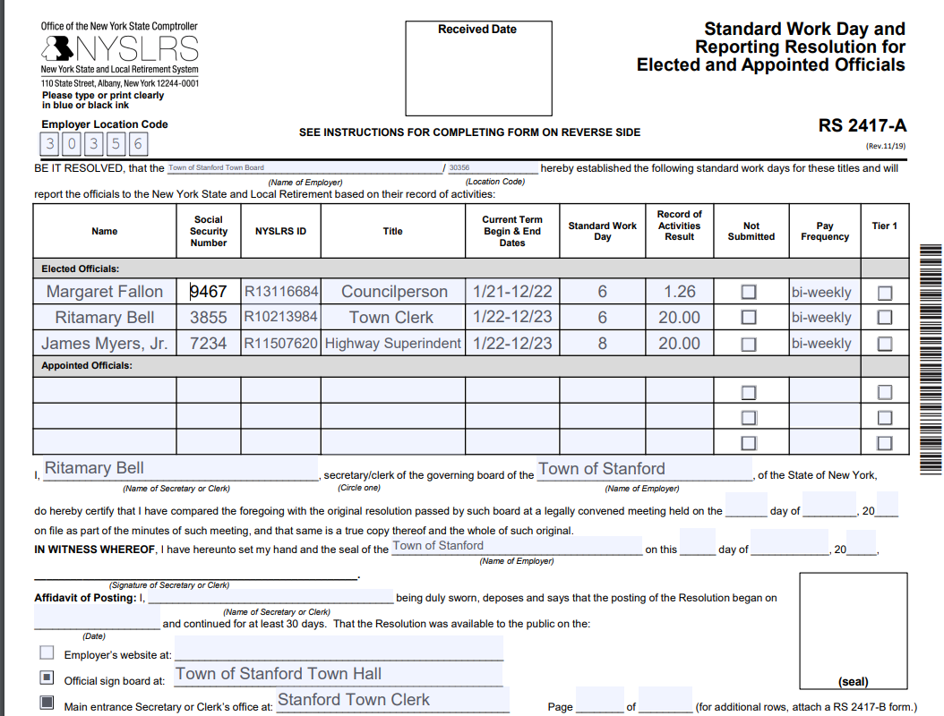
Resolution #12J OF 2021 adopted by the affirmative votes of the three Town Board members present and certified this 29th day of December 2021. Ritamary Bell, Town Clerk

6. NYMIR INSURANCE: Motion to approve insurance coverages for the 2022 Fiscal Year: Motion made by Frank Pepe, seconded by Wendy Burton as follows:
1. To accept insurance coverage with the New York Municipal Insurance Reciprocal (NYMIR - a non profit cooperative) for the 2022 fiscal year in the total amount of $47,170.47 as enumerated in the Premium Summary and the full proposal package available for review presented by Brown and Brown Insurance of the Hudson Valley, ℅ Brian Miles 625 Route 6 Mahopac, NY 10541 the agent representing NYMIR in Dutchess County. 2. To accept workers’ compensation insurance coverage with the Public Employer Risk Management Association, Inc. (PERMA - a nonprofit self-insurance pool for public entities) for the 2022 fiscal year in the total amount of $37,245 as presented by Lori Johnson, Emery & Webb, Pawling New York.
Discussion”● The NYMIR policy is more beneficial for the Town and is about $10,000 lower than the alternate insurance proposal. The cost of the policy is also approximately $4,000 under budget. ● The PERMA policy remains unchanged in cost and thus is well under budget. The Town continues a multi-year satisfactory history with this cooperative program. ● There will be additional small insurance approvals for other coverages in 2022 including the New York Voluntary Disability program.
Motion carried with all present voting in favor.

7. APPROVAL OF ABSTRACT #12B: A motion was made by Wendy Burton, seconded by Frank Pepe, to approve the second, end of year Abstract of Claims as follows: General Fund – check #s 6265-6288 in the amount of $33,633.01
Highway Fund – check #s 4018-4034 in the amount of $25,310.65
Motion carried with all present voting in favor.

14. OTHER: Supervisor Burton gave her end-of –year financial reports, which included two payroll verifications and a financial forecast: the General Fund has spent 91.31% but bills will still come in during January and February, and budget adjustments will be made as needed; the Highway Fund has spent 70% excluding future Jan. and Feb. bills but weather always impacts their numbers, and suggested that any excess funds not spent be put into the Highway Vehicle Fund. General Fund revenue was short on the Haunted Fortress as it could not open but overall the revenue came in greater than planned: mortgage tax was exceeded, probably Covid driven, and Court fees, thanks to the new prosecutor going through old backlogs. She also suggested that a reserve fund might be created with excess revenue funds to offset future years if needed, and would lower the unexpended fund balance. Highway revenue will not meet their goals because of less
CHIPS funds, and the new truck is still on order.

Town Board End of Year Minutes
12/29/21, page 6
Brief discussion followed among the Board members about having the January meetings, and public hearings, held by Zoom. The swearing in ceremony for the elected officials has been canceled.

With no other business at hand, a motion was made by Margaret Fallon, seconded by Frank Pepe, to adjourn the meeting at 7:31PM. Motion carried with all present voting in favor.

Respectfully submitted,

Ritamary Bell
Town Clerk

